**Press Release for immediate distribution**

**SLBC-Delhi Holds 120th Quarterly Meeting; Focus on Saturation Campaign for Financial Inclusion and Review of Bank Performance**

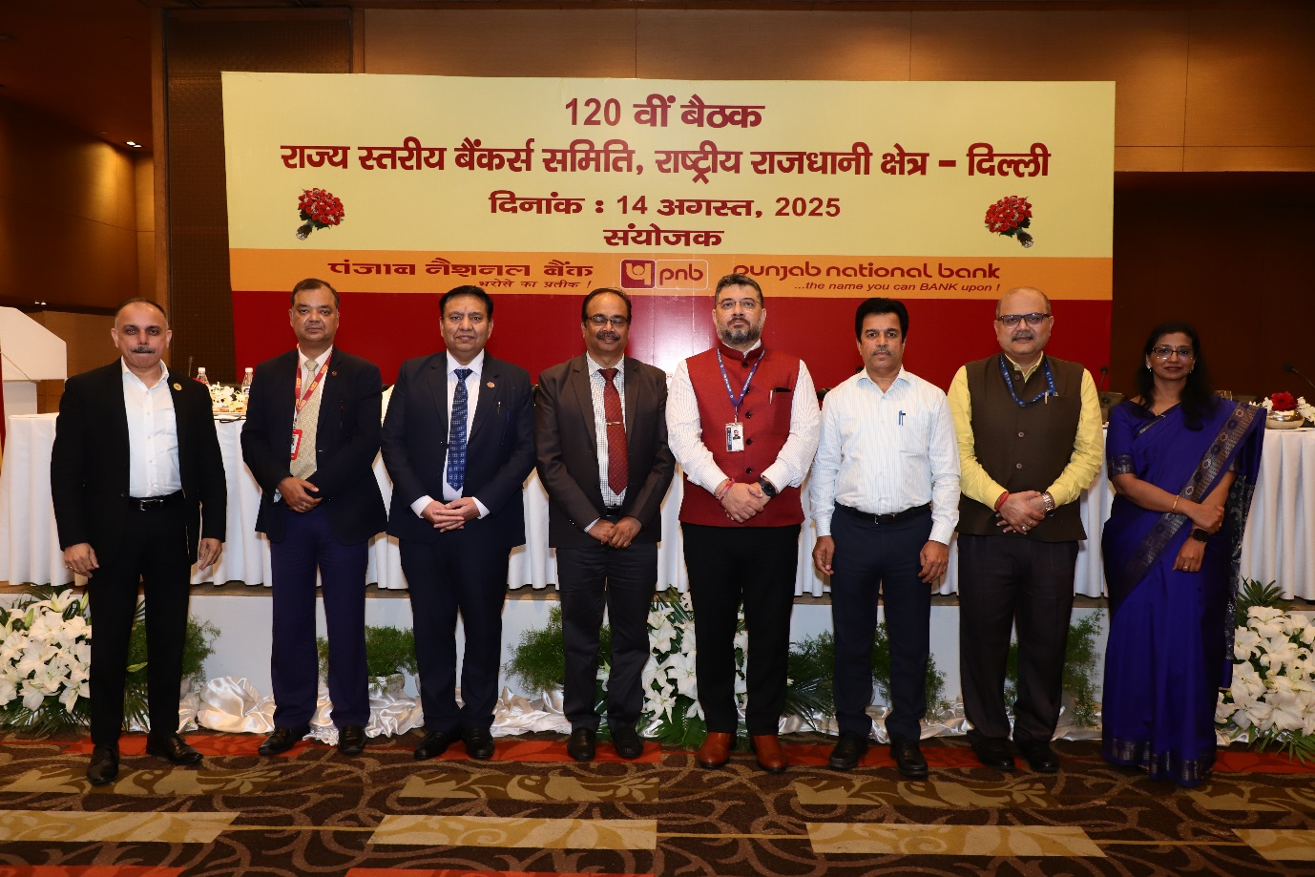

**New Delhi, 14 August 2025:** SLBC-Delhi has conducted its 120th SLBC Quarterly Meeting on 14.08.2025. The meeting was chaired by Sh. D. Surendran, Executive Director, Punjab National Bank, and attended by Sh. Rohit P. Das, Regional Director, Reserve Bank of India, Sh. S. S. Parihar, IAS, Special Secretary (Finance), GNCTD, Sh. Parveen Goyal, Chief General Manager, Punjab National Bank, Sh. Natarajan Ramachandran, General Manager- SIDBI, Mrs. Aditi Gupta, DGM-Reserve Bank of India, Sh. Rajesh Kumar, General Manager & Convener-SLBC-Delhi, Sh. Mukesh Sethi, DGM-SLBC-Delhi, member banks, Reserve Bank of India, NABARD, SIDBI, GNCTD and LDMs.

The main agenda points were ‘three months saturation campaign’, performance under various Government Schemes like PM Surya Ghar Yojana, PM Vishwakarma, PMMY etc., besides reviewing performance of the banks for the first quarter of current financial year against Annual Credit Plan target under various parameters.

The dignitaries requested member banks and LDMs to whole heartedly participate in three months saturation campaign of FI Schemes launched by Ministry of Finance. The major focus points of the campaign are opening of PMJDY accounts, enrolments under PMJJBY, PMSBY and APY, re-KYC and nomination in accounts along with awareness of digital frauds etc.

*****************