
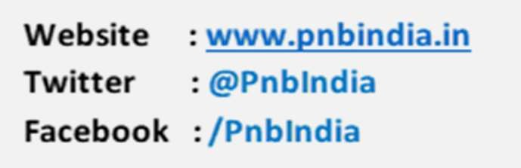

Press Release for immediate distribution
PNB Empowers Investors with Unified Demat-Trading Account Opening Journey via PNB One
New Delhi, August 04, 2025 – Punjab National Bank (PNB), India’s leading public sector bank, offers digital Integrated Demat & Trading account opening functionality. This enables customers to open both Demat and Trading accounts simultaneously through the PNB One mobile application without requiring additional KYC documentation.
The digital facility represents a significant milestone in PNB's digital transformation journey, offering customers convenience in Demat & Trading account opening. Through strategic partnership with the trading channel partners, PNB has created a unified platform that eliminates traditional barriers in Demat & Trading account opening.
Key Highlights
- Single application process: Investors can now open Demat and trading accounts using a single application, eliminating paperwork and save time.
- Seamless integration: The functionality ensures smooth integration between demat and trading accounts.
- Status Updates: Clients can manage both accounts through a unified dashboard of the trading partner, providing real-time updates and enhanced visibility.
- Comprehensive support: Dedicated customer service team available to assist clients throughout the account opening process.
Shri Binay Kumar Gupta, CGM, PNB said “We are committed to innovating and improving the overall investment experience. Our integrated demat account and trading account opening facility in collaboration with Bank’s trading partners, Aditya Birla Money Ltd. and SMC Global Securities Ltd. aims to empower investors to achieve their financial goals.”

How to Open an Account?
To open an integrated demat and trading account, customer can navigate to the ‘Popular’ section of the Bank’s mobile banking app, PNB One, and click on Demat & Trading. The service is available also on the internet banking platform.
For More Information, visit www.pnbindia.in/

