

**Press Release for immediate distribution**

**Punjab National Bank Inaugurates its 1st Startup-centric Branch** *The bank signed an MoU with STPI to offer financial support to eligible startups*

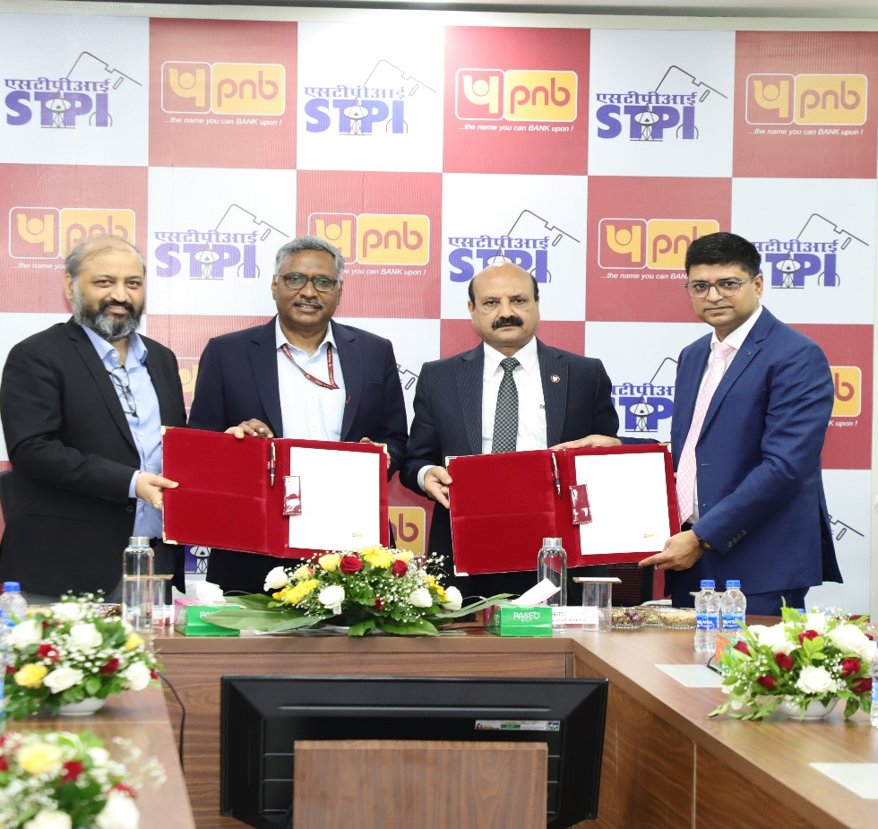

***PNB Signs MoU with STPI (L-R)*** *Shri Subodh Sachan, Director, STPI; Shri, Arvind Kumar, Director General, STPI; Shri Ashok Chandra, MD & CEO, PNB and, Shri Sudhir Dalal, GM, BA&RM, PNB.*

**New Delhi, 27 August, 2025** – Punjab National Bank (PNB), India's leading public sector bank, has inaugurated its **1st Startup-centric Branch** at Bhikaji Cama Place, New Delhi. Aligned with the Startup India initiative, this branch aims to promote entrepreneurship and supports innovation through services including all facets of banking solution**.**

The inauguration ceremony was graced by Hon'ble Chief Guest Shri Arvind Kumar, Director General, Software Technology Parks of India (STPI), and MD & CEO, Shri Ashok Chandra. The event witnessed the presence of senior dignitaries including Shri Subodh Sachan, Director STPI, and Shri Ankesh Kumar, Additional Director STPI, along with other senior officials from both PNB and STPI.

Further, an MoU was signed between PNB and STPI to extend financial support to eligible startups. Under this collaboration, STPI will play a pivotal role by sharing a curated list of incubated, onboarded, or graduated startups with the bank, acting as a bridge between the startups and financial institutions to facilitate access to PNB’s startup-focused schemes and financial products.

Speaking at the occasion, MD Shri Ashok Chandra emphasised PNB's unwavering commitment to supporting India's entrepreneurial aspirations. *"This dedicated Startup Branch offers a comprehensive and one-stop banking solution tailored to start ups. The bank’s association with STPI will boost startup ecosystem for financial solutions that will fuel the growth of emerging entrepreneurs.”*

Shri Arvind Kumar, Director General, STPI, lauded PNB's initiative, stating that this collaboration will create a robust ecosystem for startups, combining STPI's technological expertise with PNB's banking excellence.

For more information visit the branch at Bhikaji Cama Place, New Delhi and www.pnb.bank.in.

**\*\*\*\*\*\*\*\***