

**Press Release for immediate distribution**

**PNB signs MoU with Central Reserve Police Force**

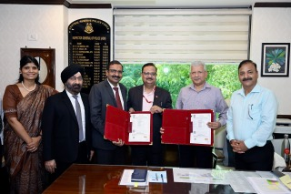

**New Delhi, 22 August 2025:** Punjab National Bank (PNB), India’s leading public sector bank, has signed an MoU with Central Reserve Police Force. PNB is offering bouquet of services with enhanced Insurance Coverage and other benefits to all the serving personnel and pensioners of the CRPF under the bank’s flagship scheme of “PNB Rakshak Plus”.

The addendum to its existing MoU was exchanged in presence of Shri. Bibhu Prasad Mahapatra, Executive Director, PNB and Sh. D S Negi, DIG(Adm) CRPF at office of Directorate General of Central Reserve Police Force, CGO Complex, Lodhi Road, New Delhi-110003.

MoU was signed by Shri. Binay Kumar Gupta, Chief General Manager PNB & Sh. Zaki Ahmad, IPS, Inspector General of Police (Adm), Directorate General, CRPF, New Delhi in presence of other senior officials of Bank & CRPF.

In addition, several benefits are being offered to the dependents and families of Rakshak Account Holder.

The Bank is dedicated in its commitment to the Central Armed Police Forces and will strive to continue doing the same in future as well.

*****************